## Business screen

1. Business screen

<screen’s component list, table below is suggestion>

|  |  |  |  |  |  |
| --- | --- | --- | --- | --- | --- |
| **No** | **Component Name** | **Required** | **Format** | **Reference** | **Note** |
|  | Trang cá nhân |  |  | *Use Linearlayout:*  *Use ImageView:*   * *width: 20dp* * *height: 30dp*   *Use TextView:*   * *TextSize: 16dp* * *Color: #435154* * *TextStyle: Bold* |  |
|  | Chỉnh sửa bài đăng |  |  | *Use Linearlayout:*  *Use ImageView:*   * *width: 20dp* * *height: 30dp*   *Use TextView:*   * *TextSize: 16dp* * *Color: #435154* * *TextStyle: Bold* |  |
|  | Danh sách tour |  |  | *Use Linearlayout:*  *Use ImageView:*   * *width: 20dp* * *height: 30dp*   *Use TextView:*   * *TextSize: 16dp* * *Color: #435154* * *TextStyle: Bold* |  |
|  | Tour khách đặt |  |  | *Use Linearlayout:*  *Use ImageView:*   * *width: 20dp* * *height: 30dp*   *Use TextView:*   * *TextSize: 16dp* * *Color: #435154* * *TextStyle: Bold* |  |
|  | Đăng xuất |  |  | *Use Linearlayout:*  *Use ImageView:*   * *width: 20dp* * *height: 30dp*   *Use TextView:*   * *TextSize: 16dp* * *Color: #435154* * *TextStyle: Bold* |  |

## Infor Business screen

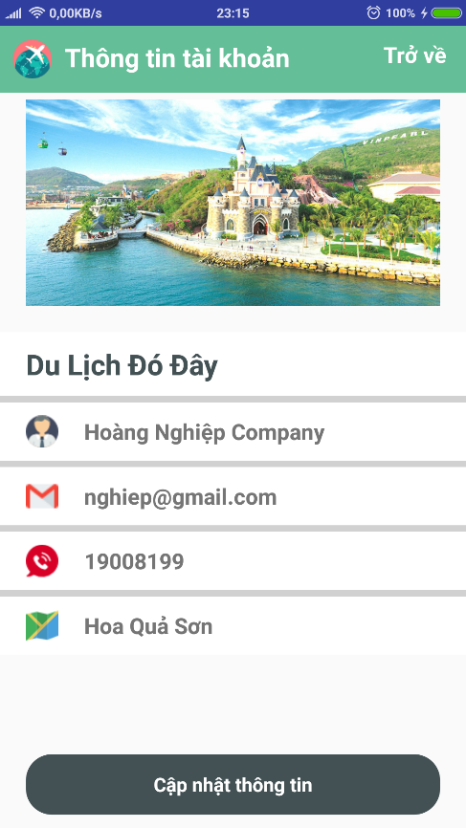

2. Infor Business screen

<screen’s component list, table below is suggestion>

|  |  |  |  |  |  |
| --- | --- | --- | --- | --- | --- |
| **No** | **Component Name** | **Required** | **Format** | **Reference** | **Note** |
|  | ImageView |  |  | *Use ImageView* |  |
|  | Name Business |  |  | *Use TextView:*   * *TextSize: 22dp* * *Color: #435154* * *TextStyle: Bold* |  |
|  | Email business |  |  | *Use TextView:*   * *TextSize: 17dp* * *Color: #435154* * *TextStyle: Bold* |  |
|  | Phone business |  |  | *Use TextView:*   * *TextSize: 17dp* * *Color: #435154* * *TextStyle: Bold* |  |
|  | Address |  |  | *Use TextView:*   * *TextSize: 17dp* * *Color: #435154* * *TextStyle: Bold* |  |

## Update infor Business screen

3. Update Infor Business screen

<screen’s component list, table below is suggestion>

|  |  |  |  |  |  |
| --- | --- | --- | --- | --- | --- |
| **No** | **Component Name** | **Required** | **Format** | **Reference** | **Note** |
|  | ImageView |  |  | *Use ImageView:* |  |
|  | Ô Tên doanh nghiệp |  |  | *Use EditText*  *singleLine="true"*  *Color: #435154* |  |
|  | Ô Số điện thoại |  |  | *Use EditText*  *singleLine="true"*  *Color: #435154* |  |
|  | Ô Địa chỉ |  |  | *Use EditText*  *singleLine="true"*  *Color: #435154* |  |
|  | Nút Cập nhật thông tin |  |  | *Use TextView:*  *Gravity: center*  *TextSize: 15dp*  *TextStyle: bold*  *Color: #FFFFF* |  |
|  |  |  |  |  |  |

## Manager tour screen

4. Manager tour screen

<screen’s component list, table below is suggestion>

|  |  |  |  |  |  |
| --- | --- | --- | --- | --- | --- |
| **No** | **Component Name** | **Required** | **Format** | **Reference** | **Note** |
|  | Tour item |  |  | *Use RecyclerView custom* |  |
|  | Butom Add |  |  | *Use ImageView*  *Width="40dp"*  *Height="40dp"* |  |
|  | Image tour |  |  | *Use ImageView*  *Width: 120dp*  *Height: 120dp* |  |
|  | Id tour |  |  | *Use TextView*  *TextStyle: bold*  *TextColor: #64be97* |  |
|  | Name tour |  |  | *Use TextView*  *TextColor: #000000*  *TextSize: 17sp* |  |
|  | Time Tour |  |  | *Use TextView*  *TextSize: Default* |  |
|  | Price tour |  |  | *Use TextView*  *TextColor: Red_dark*  *TextSize: Default* |  |
|  | Menu Tour |  |  | *Use TextView*  *TextSize: Default* |  |

## Add tour screen

5. Add Tour screen

<screen’s component list, table below is suggestion>

|  |  |  |  |  |  |
| --- | --- | --- | --- | --- | --- |
| **No** | **Component Name** | **Required** | **Format** | **Reference** | **Note** |
|  | ImageView |  |  | *Use ImageView*  *Width="150dp"*  *Height="150dp"* |  |
|  | Chọn miền |  |  | *Use RadioButton*  *TextColor="#ffffff"*  *TextStyle="bold"*  *TextSize="Default"* |  |
|  | Ô Mã tour |  |  | *Use EditText*  *SingleLine="true"*  *Color: #435154* |  |
|  | Ô tên tour |  |  | *Use EditText*  *SingleLine="true"*  *Color: #435154* |  |
|  | Ô thời gian |  |  | *Use EditText*  *SingleLine="true"*  *Color: #435154* |  |
|  | Ô mô tả chi tiết |  |  | *Use EditText*  *SingleLine="true"*  *Color: #435154* |  |
|  | Ô giá tiền |  |  | *Use EditText*  *SingleLine="true"*  *Color: #435154* |  |
|  | Nút thêm |  |  | *Use TextView*  *gravity="center"*  *textSize="15dp"*  *textStyle="bold"*  *textColor="#ffffff"* |  |

## Update Tour screen

6. Update Tour screen

<screen’s component list, table below is suggestion>

|  |  |  |  |  |  |
| --- | --- | --- | --- | --- | --- |
| **No** | **Component Name** | **Required** | **Format** | **Reference** | **Note** |
|  | ImageView |  |  | *Use ImageView*  *Width="150dp"*  *Height="150dp"* |  |
|  | Chọn miền |  |  | *Use RadioButton*  *TextColor="#ffffff"*  *TextStyle="bold"*  *TextSize="Default"* |  |
|  | Ô mã tour |  |  | *Use EditText*  *SingleLine="true"*  *Color: #435154* |  |
|  | Ô tên tour |  |  | *Use EditText*  *SingleLine="true"*  *Color: #435154* |  |
|  | Ô thời gian |  |  | *Use EditText*  *SingleLine="true"*  *Color: #435154* |  |
|  | Ô mô tả chi tiết |  |  | *Use EditText*  *SingleLine="true"*  *Color: #435154* |  |
|  | Ô giá tiền |  |  | *Use EditText*  *SingleLine="true"*  *Color: #435154* |  |
|  | Nút cập nhật |  |  | *Use TextView*  *gravity="center"*  *textSize="15dp"*  *textStyle="bold"*  *textColor="#ffffff"* |  |

## Tour List screen

7. Tour list sscreen

<screen’s component list, table below is suggestion>

|  |  |  |  |  |  |
| --- | --- | --- | --- | --- | --- |
| **No** | **Component Name** | **Required** | **Format** | **Reference** | **Note** |
|  | Item tour |  |  | *Use RecyclerView custom* |  |
|  | Image tour |  |  | *Use ImageView*  *Width: 120dp*  *Height: 120dp* |  |
|  | Tour ID |  |  | *Use TextView*  *TextStyle: bold*  *TextColor: #64be97* |  |
|  | Tour name |  |  | *Use TextView*  *TextColor: #000000*  *TextSize: 17sp* |  |
|  | Tour Time |  |  | *Use TextView*  *TextSize: Default* |  |
|  | Tour Price |  |  | *Use TextView*  *TextColor: Red_dark*  *TextSize: Default* |  |

## Manager Book Tour screen

8. Manager book tour sscreen

<screen’s component list, table below is suggestion>

|  |  |  |  |  |  |
| --- | --- | --- | --- | --- | --- |
| **No** | **Component Name** | **Required** | **Format** | **Reference** | **Note** |
|  | Item tour |  |  | *Use RecyclerView custom* |  |
|  | Name user |  |  | *Use TextView*  *TextSize="25sp"*  *TextColor="#000000"* |  |
|  | Image tour |  |  | *Use ImageView*  *Width: 120dp*  *Height: 120dp* |  |
|  | Tour ID |  |  | *Use TextView*  *TextStyle: bold*  *TextColor: #64be97* |  |
|  | Tour name |  |  | *Use TextView*  *TextColor: #000000*  *TextSize: 17sp* |  |
|  | Tour Time |  |  | *Use TextView*  *TextSize: Default* |  |
|  | Tour Price |  |  | *Use TextView*  *TextColor: Red_dark*  *TextSize: Default* |  |